DOCUMENTATION & STATUS REPORT
Team charter
Names and ids
1.Shaiza Parveen (f20242661332)
2.Amna Nasrullah(f2024266096)
3.Muhammad Haris usman (f2024266948)

Status report
Activities Completed:
- Successfully parsed the raw PCAP file using Wireshark filters.
- Isolated the victim host MAC/IP addresses (192.168.100.103).
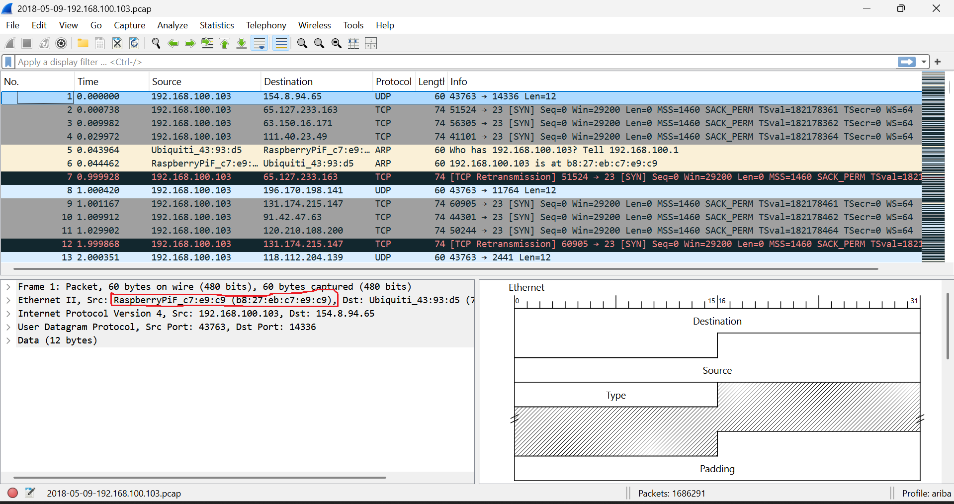
Milestones Achieved:
- Mapped the external Command & Control (C2) server IPs (219.243.27.65 & 71.181.6.40).
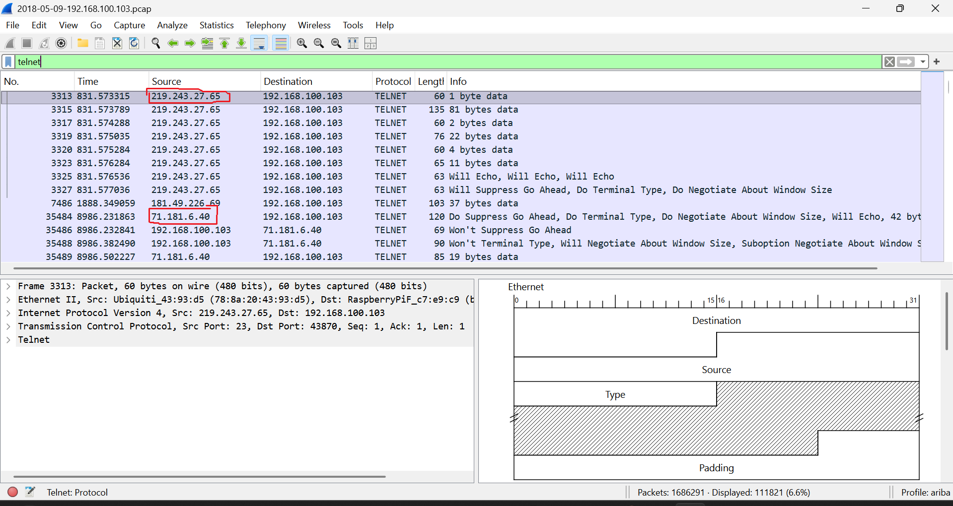
- Identified the plaintext Telnet brute-force attempts from TCP stream logs.
